**The Confusion Matrix**

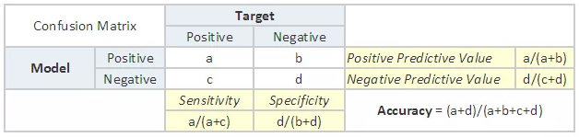

* **Accuracy**: the proportion of the total number of predictions that were correct.
* **Positive Predictive Value or Precision**: the proportion of positive cases that were correctly identified.
* **Negative Predictive Value**: the proportion of negative cases that were correctly identified.
* **Sensitivity or Recall**: the proportion of actual positive cases which are correctly identified.
* **Specificity**: the proportion of actual negative cases which are correctly identified.

References:

1. 7 Important Model Evaluation Error Metrics Everyone should know [http://www.analyticsvidhya.com/blog/2016/02/7-important-model-evaluation-error-metrics/]